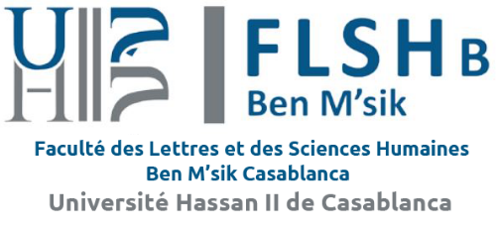

Festival International de Théâtre Universitaire de Casablanca
International University Theater Festival of Casablanca

34ème édition /34rd edition
Du 23-28 Juillet 2022/ 23-28 July 2022

Thème : Réinventer le théâtre
Theme: Reinventing the Theater

PARTICIPATION RULES

SECTION 1
Faculty of Arts and Humanities Benmsik Casablanca organizes the International University Theatre Festival of Casablanca. FITUC is an artistic event that aims to:
- promote the creation of young artists/ students;
- build networking among directors, artists, and students throughout the world;
- promote artists, director and actors.
- encourage cultural and artistic exchange among young artists/students throughout the world.
SECTION 2
The FITUC targets university students, and academia.
SECTION 3
The 34rd edition of FITUC is held on 23-28 July 2022 in Casablanca, Morocco, in places that are listed in the brochure of the Festival, under the theme “Reinventing the Theater”
- The FITUC reserves the right to cancel or change the dates and venues of the event.
SECTION 4
- The duration of theatre pieces proposed: (maximum 60 minutes).
- The deadline for submission of theatrical pieces filmed for the selection is 23/06/ 2022.
- Applications to participate are sent to
E-mail: fitucfituc@gmail.com// agonegai@hotmail.com

SECTION 5
- directors should submit only one piece/play.
SECTION 6
- Each piece must be accompanied by a participation form and signed rules of participation.
SECTION 7
- The festival's artistic committee refuses the theatrical parts promoting violence, racisme and / or pornography.
SECTION 8
- The directors whose plays have been selected by the jury will be notified by mail before 30 Jun 2022.
SECTION 9
- As for a professional request, the Committee will forward details of directors and actors.
SECTION 10
- The festival has the right to broadcast the show online.
- The festival has the right to program the show more than one time.
SECTION 11
- The Festival supports the accommodation, catering and transport in Casablanca of the company members accepted at the Festival (10 persons maximum per company), and this during the festival period between 23-28 July 2022.
SECTION 12
The Festival does not take in charge transportation outside Casablanca.
SECTION 13
Personal insurance is necessary for each member of the company.
SECTION 14
The Festival does not support the family or friends accompanying the company during their visits to FITUC.
- The festival has the right to post the show on the web.
- The festival has the right to program the show more than one time.
SECTION 15
Participation in FITUC implies acceptance of the acts in this documents, which must be duly signed and sent to the Directorate of FITUC with the link of the play.
SECTION 16
The participation form and link of the play must be sent by email to the following address: fitucfituc@gmail.com with photographs of a few scenes from the play.
SECTION 17
FITUC can broadcast the festival activities in different screens installed at the site of the Festival.

SECTION 18
All disagreements are subject to Moroccan law and jurisdiction of the Courts of Casablanca.
TO SEND WITH YOUR link BEFORE 23 /06/ 2022.
I have read the rules and I have approved the contents with my signature.

Send to:
E-mail: fitucfituc@gmail.com// agonegai@hotmail.com
Site : www.flbenmsik.ma
www.fituc.ma
--------------------------------------------
Phone: 00 212 579826811
Fax: 00 212 522 70 51 00
President du festival: 00 212 661 634 957
--------------------------------------------
Faculté des Lettres et des Sciences Humaines,
Ben M’Sik, BP 7951 Hay El baraka Casablanca/ Maroc

